Project Proposal

1. Project Description

Project name: Arrow

In this game, player controls an arrow to go left or right to avoid colliding with obstacles. The player can control the arrow either by mouse or by key commands. Although the player cannot control the arrow to go forward or backward, the arrow progresses on the map by itself. The player gains a point if the arrow successfully survives for 2 more seconds. There is no upper bound of how much points a player can gain (the game is in endless mode!).

1. Competitive Analysis

My game is inspired by “The Line Zen” and “Dancing Line”, which are games on mobile phone. “Arrow” will be similar to these games in basic rules, such as how the arrow moves and game ends with collision. However, I will add more features like: 1) opponent can control the obstacles in competition mode 2) the arrow can change color for a short time so the collision rule does not work on it for the amount of time. 3) the previous high scores are saved in the score list 4) I will possibility develop multiplayer mode and music mode (the difficulty of the game depends on the beats of the music given) after TP2.

1. Structural Plan

All files are going to be organized into Tech Demo, TP1, TP2, and TP3 folders. Under each folder, images are saved in their own image folder. For start of each phase, I will open a new python file named after TP#, so I can keep track of my progress and go back as I desire. All individual features are going to be organized into separate files, so I can easily import them and use them.

1. Algorithmic Plan

The trickiest part of my project is to make an endless map. To approach this problem, I am going to make a 2D list that saves all locations of my map, and randomly generate more locations in timerFired. To make my program run smoothly, I will remove previous locations. In addition, I think obstacles are also a big difficult part in my project. I will create some sample obstacles in several classes, and randomly put them onto my map.

1. Timeline Plan

April 21: Main Framework due (no difficulty increases but arrow is able to move and the map is able to progress)

April 23: Increasing difficulty with more randomly generated obstacles

April 25: TP2 meeting

April 28: More features added to the project. Able to work fluently

May 2: Check all bugs and make sure the project work smoothly and efficiently

May 3: submit the project

1. Version Control Plan

I will use Github to back up my code daily. 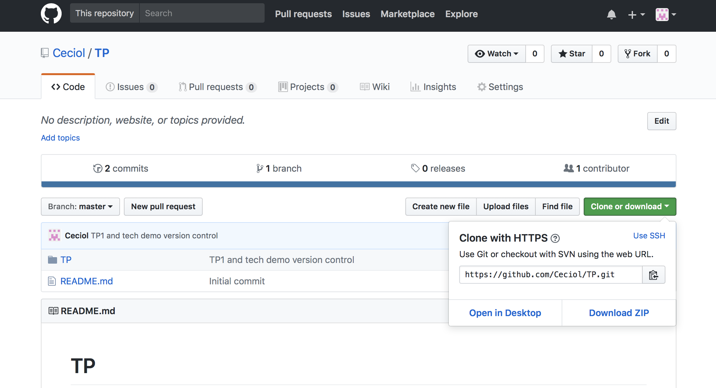

1. Module List

Python

Pygame

(socket if I finished my project early)